Set up Kafka on Windows

By Goutam Chowdhury

1. JDK 1.8 Download and install (**ignore if already installed**)

<http://www.oracle.com/technetwork/java/javase/downloads/jdk8-downloads-2133151.html>

1. Set environment variables (**ignore if already done**)
   1. User Variable:

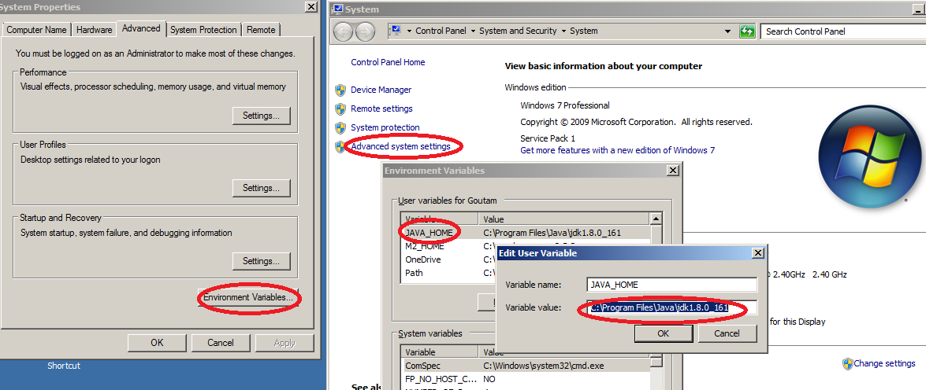

* 1. System variables:

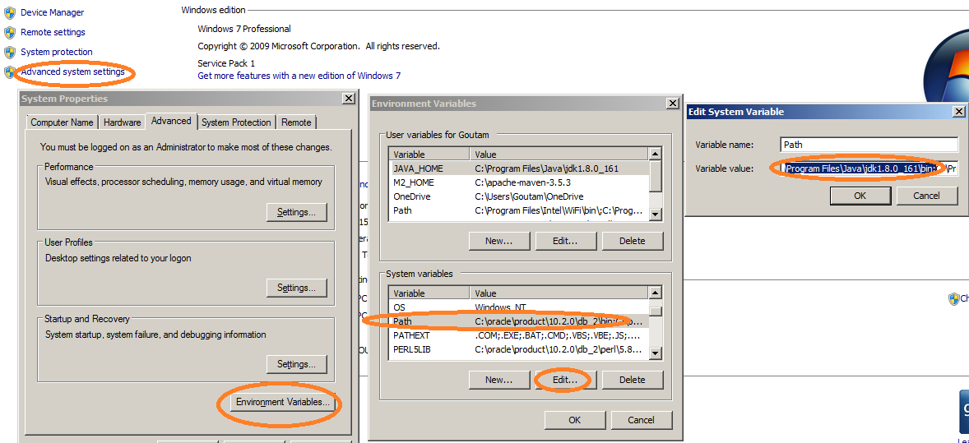

1. Verify JDK path

echo %JAVA_HOME%

echo %path%

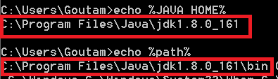

1. Verify JDK version:

java -version

javac -version

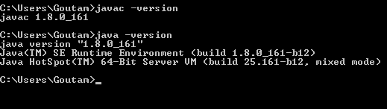

1. Download and install 7-zip from

<http://www.7-zip.org/download.html>

Please use it for unzipping anything for this setup

1. Download and install eclipse oxygen( or Any other version of “Java-developers” )

<http://www.eclipse.org/downloads/packages/release/oxygen/m2/eclipse-ide-java-developers>

After installation , create a “hello world” program and run the same to make sure everything is working fine.

1. Download Kafka folder from below link and place it in C:\

<https://drive.google.com/open?id=1XIsxL5dZKyAgDnauTEeslgaH3xwerl4F>

It will look like below

